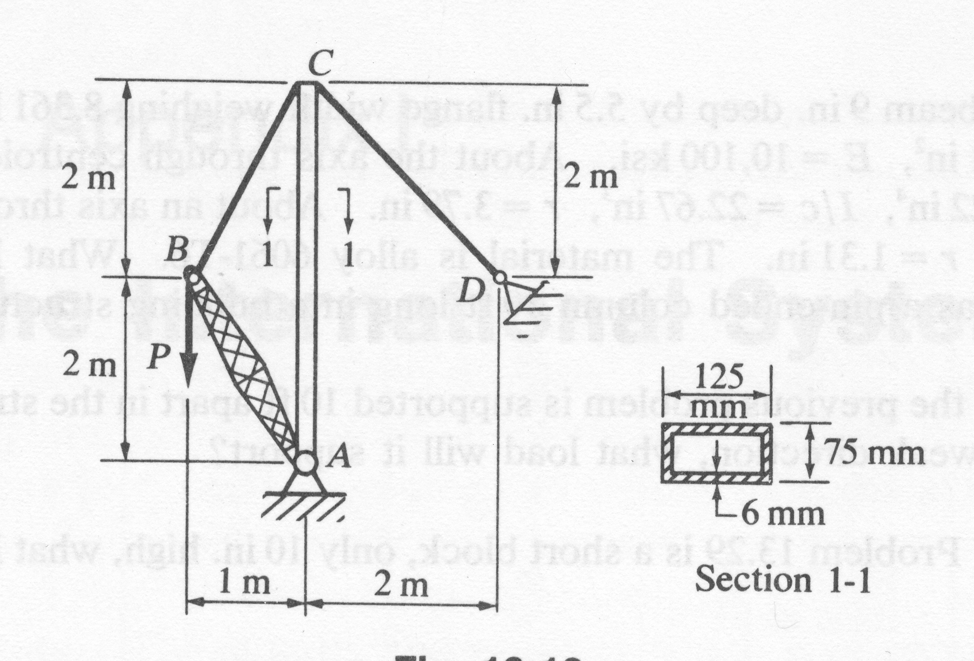
Problem 13: what vertical load P will the derrick carry if the capacity is determined by the mast? The mast is a rectangular structural steel tubing 125x75mm by 6mm thick. Its cross-sectional area is 2250mm² and its radius of gyration in the weak direction is 30mm. All joints are pin-connected, the top of the mast is guyed laterally to keep it from moving sideways, and the load at the top is applied concentrically. Use a factor of safety of 2, and let E=200GN/m³. Hint: Snce L/ρ=4mm/30mm, Euler’s formula is applicable.

